|  |
| --- |
| **Data Structures and Algorithms**  **Pizza Online Shop** |
|  |

**Loreto Jr. Esmenio Briones**

Contents

**Introduction** 3

**Test run based on the direct functions** 3

**Function testing and error handling** 5

Scenario one “Nothing is being selected” 5

Scenario Two “Only pizza type has been selected” 6

Scenario Three “No drinks and drinks only” 6

Scenario Four “Continue ordering or exit” 8

Scenario Five “Accidentally press Exit ” 9

# **Introduction**

This Pizza Online Shop is a java application that allow user to select pizza type, sizes and drinks. The application is using three dropdown menus, which allow users to have control on selecting what option they want. When they finally decided what they want? There are four buttons on the bottom part of the application that give instruction to the application, whether to show total cost, submit order, or exit the program whenever they want to. While add delivery cost button has special function to add a delivery cost with the total cost of the order.

There are equivalent price in every selection and the application will collect all the data and sum up the total of it. Finally, when user finished selecting items the application will create a receipt or summary outline of order for the users to proof read their order.

# **Test run based on the direct functions**

Below is the welcome scree when the application is run by the user. As shown in the Figure 1, to make order, users need to select Pizza type, size and drinks. Then decide whether to add delivery cost or not, by selecting and clicking the button. Then user may check the total by clicking the show total cost to take a proof reading. Then by clicking submit order to confirm order, and exit the application when done ordering.

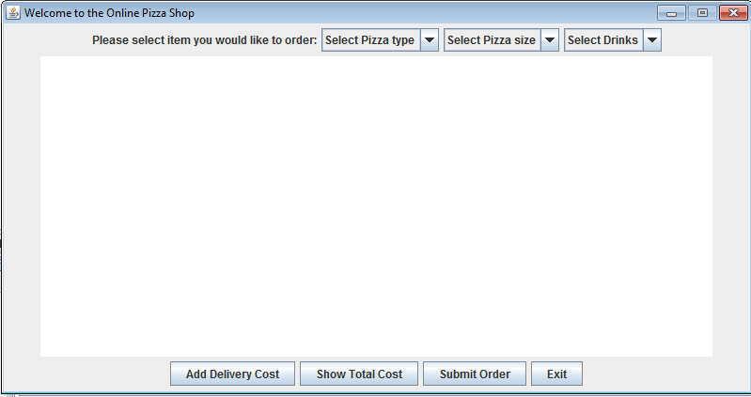

Figure 1 Welcome Screen

When user click Add Delivery Cost the text will display in the text area and add $4 to the user

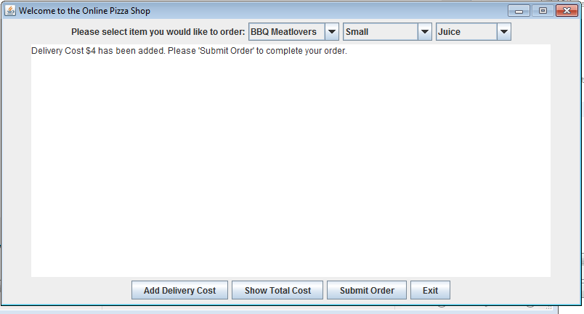

Figure 2 Add Delivery Cost

To view total cost click Show Total Cost button as shown in Figure 3.

|  |  |
| --- | --- |
| BBQ Meatlovers Small | $7.0 |
| Juice | $2.5 |
| Delivery Cost | $4.0 |
| Total Cost | $13.5 |

Table list of item selected

The Table 1 is a recap of the user selection that is why the total is $13.5.

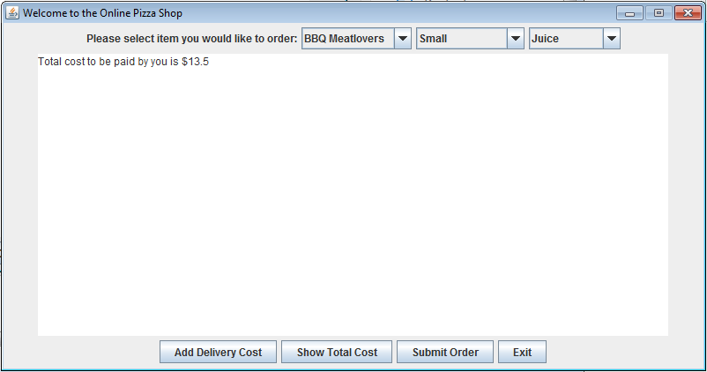

Figure Show Total Cost

Then when user click “Submit Order” it will outlined the summary of the order as shown in figure 4.

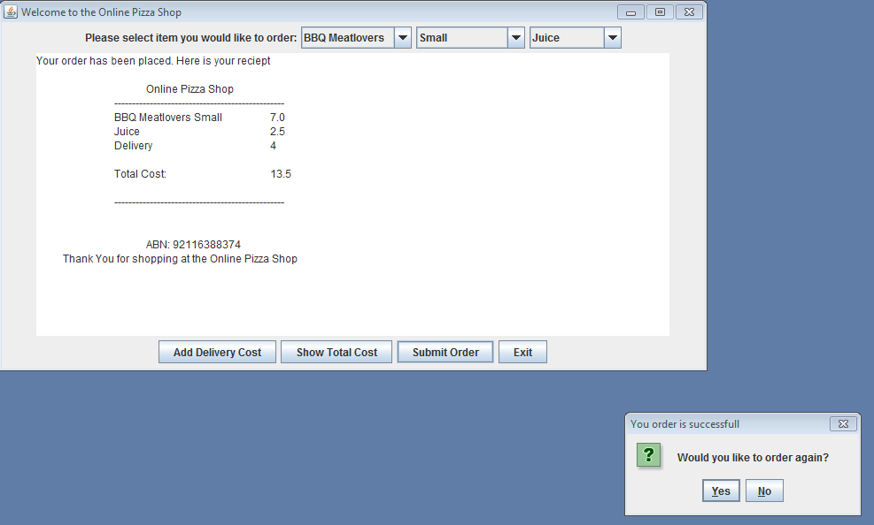

Figure 4 Submit Order

Now, you will noticed additional feature called dialog message. This is to give user a chance to order again after finishing the order.

# **Function testing and error handling**

## Scenario One “Nothing is being selected”

When nothing is being selected any in the combo box, then user click any button in the bottom. The warning message will appear saying “Please select Pizza type, size and drinks”. As shown in Figure 5. User just need to click ok and select the required data.

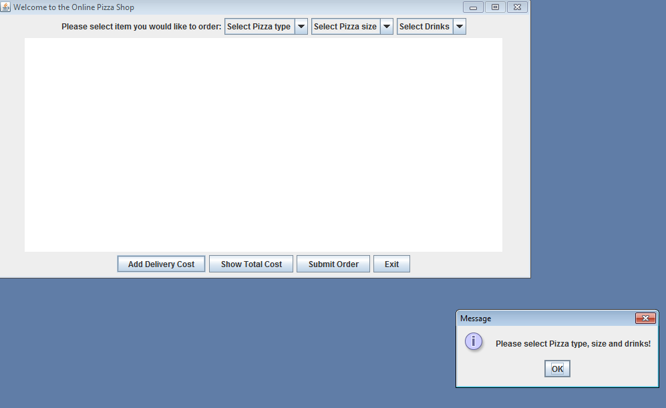

Figure 5 No item selected

## Scenario Two “Only pizza type has been selected”

When user only selected Pizza type and click “Show Total Cost” message will appear as shown in the

Figure 6, so user needs to click “ok”, and then select the required data.

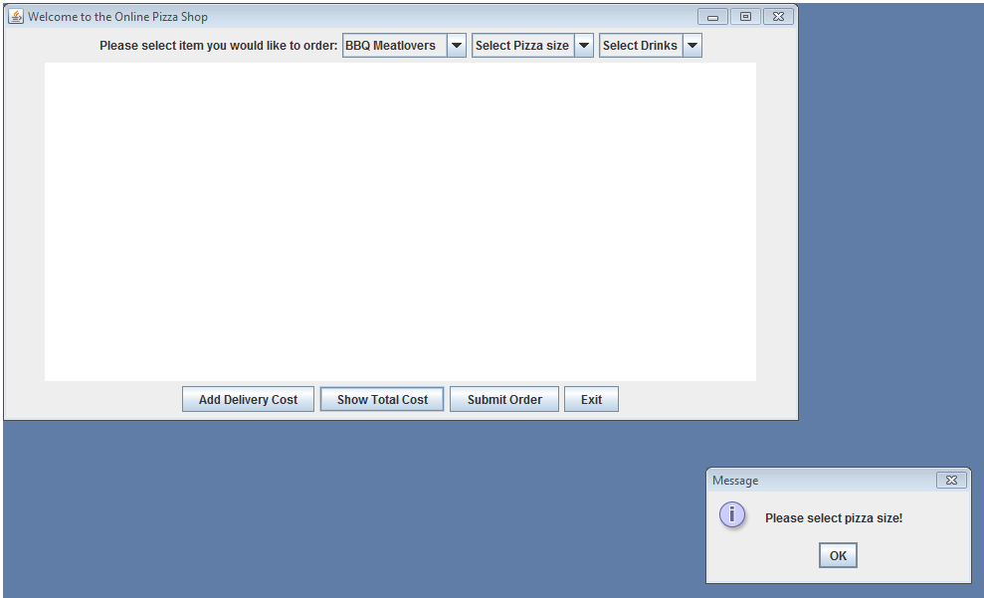

Figure 6 Only Pizza type is selected

## Scenario Three “No drinks and drinks only”

When user did not picked drinks, a message will appear as shown in the Figure 7. User will see the total amount without the drinks and user needs to click OK to continue to submit order.

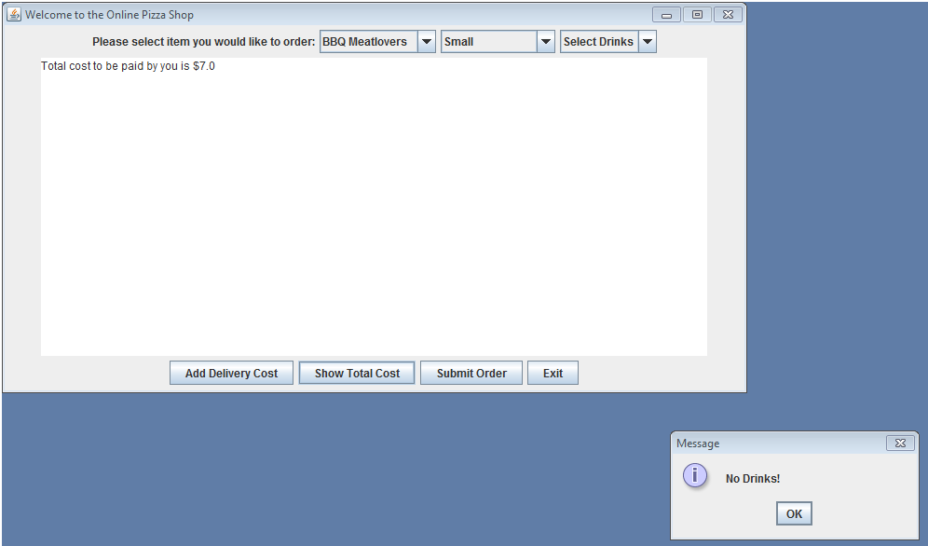

Figure No drinks

In continuation to “no drinks” it will also reflect on the receipt,

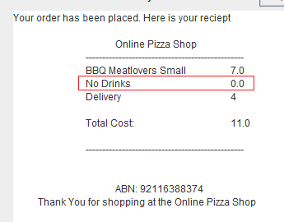

Figure No drinks receipt

and when on drinks are selected a message will appear for the user reminding that only drinks are being order. In can view the total and user need to click Submit Order to continue the processing the order.

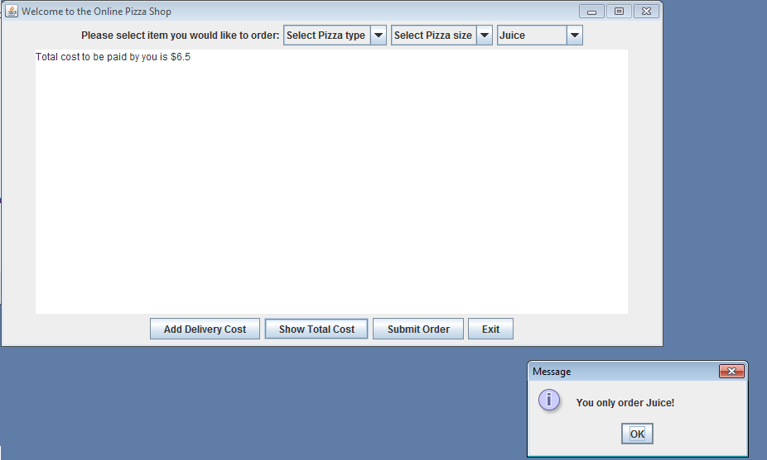

Figure Only drinks ordered

When customer submit order.

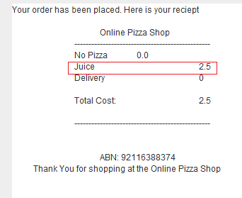

Figure 10 Receiptfor only drinks order

## Scenario Four “Continue ordering or exit”

When the user clicked Submit Order a message will going to appear, and ask the user if they want to continue ordering or not, as shown in the figure 11.

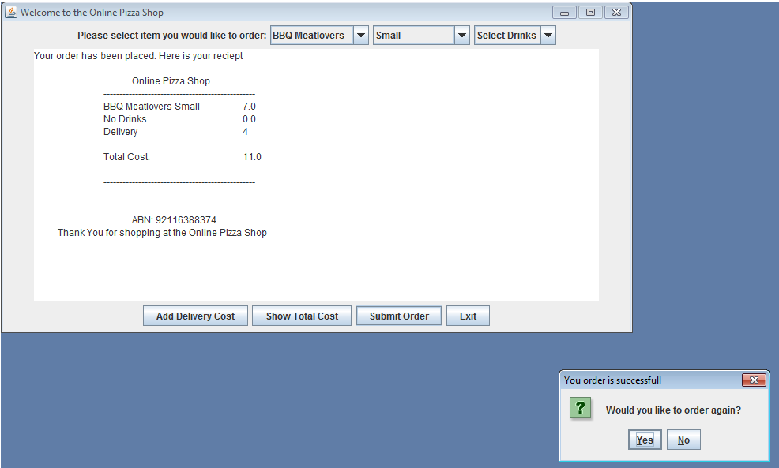

Figure 11 Submit order (Continue Yes or No?)

When user clicked “Yes” the application will clear the text area and the user can select order again as show in Figure 1.

And when user clicked “No” Application will exit.

## Scenario Five “Accidentally press Exit”

When the user click exits it will not exit straight away, but ask the user instead, if they want to exit the application or not as shown in the Figure 12.

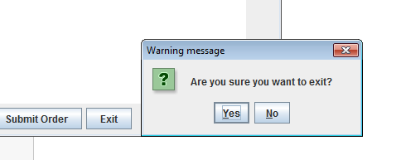

Figure 12 Exit or not

The reason why this condition is being placed is because users are prone to accidentally press a button that they do not meant.